**Assessment Task 2 - Number Conversion Problems**

Thomas Jackson  
AIE Adelaide – Game Programming

**Question 1:**

How many unique colour values can the colour variable contain?

8 Bits = 1 Byte

8 * 4 = 32 Bits = 4 Bytes

2^32 = 4,294,967,296

**Question 2:**

What is the minimum value, maximum value, and range for each colour component?

The minimum value is 0, maximum is 255, the range is 256.

**Question 3:**

Suppose the *red* component of the RGBA colour is to be stored in an 8-bit integer (char) variable, and is set to the decimal value

char red = 94

Write this value as a binary number

| 128 | 64 | 32 | 16 | 8 | 4 | 2 | 1 |

= 0 1 0 1 1 1 1 0

= 64 + 16 + 8 + 4 + 2 = 94

**Question 4:**

The byte containing the red value (94) from question 3 is now to be stored in the RGBA colour value (in the left-most byte).

Assuming all other colour bytes are initialized to 0, write the value of the 4-byte colour variable in binary.

= 01011110 00000000 00000000 00000000

**Question 5:**

What is the decimal value of the binary number from question 4?

= 1,577,058,304

**Question 6:**

Write the bit shifting operation (in C#) that will move all bits from the ‘R’ position in the colour variable to the ‘G’ position.

UInt32 colour = 0x5E000000; // RR,GG,BB,AA // 01011110 00000000 00000000 00000000

colour = colour >> 8; // Shift colour by 8 bits (1 byte) to the right.

**Question 7:**

Our colour value now has the green colour component set, and no red, blue, or alpha colour component values.

What are the decimal and binary value of the *colour* variable now?

= 00000000 01011110 00000000 00000000 // Binary

= 6,160,384 // Decimal

**Question 8:**

After you have created your Colour class and implemented all the functions listed in the class definition above, add at least 1 new unit test to the unit test program using your answers in this exercise to verify your code.

= ByteTest(), ColourRedTest(), ColourTest(), ColourShiftTest()

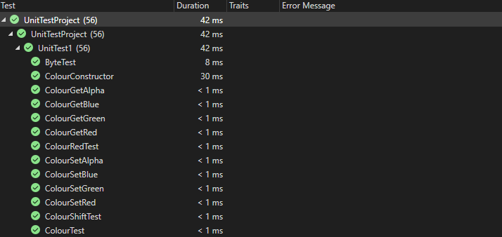 Question 1, Question 3, Question 4/5, Question 6/7